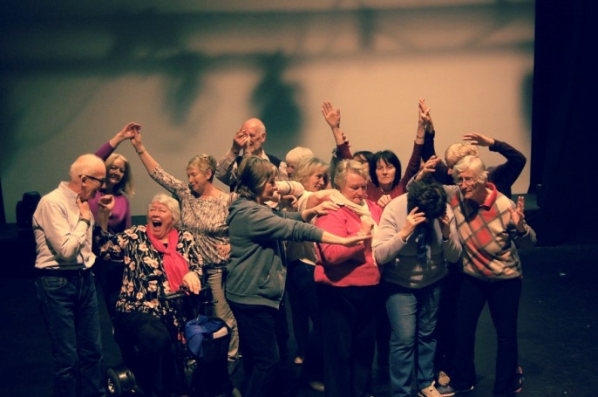
Press Release
For immediate release

The Mellowing Stars premiere at dlr Mill Theatre

Dún Laoghaire-Rathdown County Council and dlr Mill Theatre, Dundrum, are delighted to present Life Memos, a new specially created performance by the Mellowing Stars. The show will take place on Wednesday 27 June at 7.30pm; tickets are free but booking is essential.
The Mellowing Stars began working together in March 2018, with theatre artist Andrea Scott. Experienced in life but new to theatre-making they have been working collaboratively to create, stage and perform an original show. Life Memos is a testimony to lives lived and experienced. Memories are brought to life through story, image and movement.
Andrea is the artistic director of Floating World Productions and has extensive experience in theatre, and in facilitating a diverse range of groups. She says of The Mellowing Stars: “It has been an absolute pleasure to work with this wonderful group for the past four months. They have been open and creative throughout sharing stories and ideas with me…”
This project is part of the County Council’s public art programme and it aims to create new work while engaging with the wider community in the Dundrum area. It has been supported and managed by the team in dlr Mill Theatre.

To book your free ticket for the event, phone the dlr Mill Box Office at 01 296 9340 or book online at www.milltheatre.ie

