******Traffic Management for**

**Frog Migration on the Barnacuilla Road**

From **March 9th to March 30th** in the evenings from **19:00 -22:00hrs**. See map attached for Location.

Traffic will be requested to reduce speed and you may be asked to stop for a short period of time.

Please take your time on this road as volunteers will be on the road in different locations.

Please obey the signs and the instructions of the Patrol Leaders who will be managing the traffic.

Please note that the timing of amphibian migrations is not an exact science so some nights may be very busy and will continue later into the night, and others may see no movement at all and be completed earlier.



**Location Map for**

**Frog and Toad Migration Traffic Management**

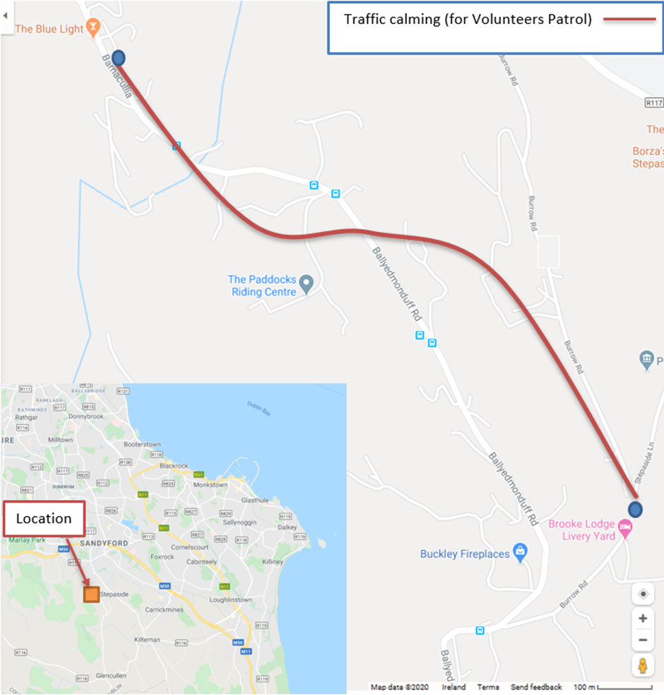

DLR and the HSI wish to thank the public for their cooperation and please contact the HSI at [info@thehshi.org](mailto:info@thehshi.org) for further information and to sign-up as a volunteer.

Please don’t turn up unannounced as you will not be covered under Health and Safety and our assessment protocols. You may also unintentionally add to the Patrol Leaders workload on a busy night.