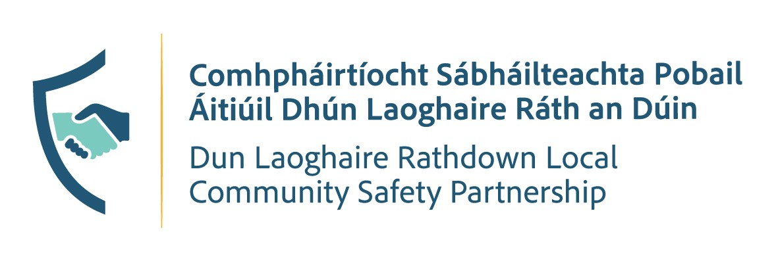

PUBLIC MEETING
📅 Wednesday 2nd December 2026
📍 Assembly Room, Dun Laoghaire County Council

Schedule
🕔 2:00 PM - 4:00 PM - Public Meeting

Have Your Say
Join us to discuss local community safety priorities and contribute your views on issues affecting the area.
All members of the public are welcome to attend.

