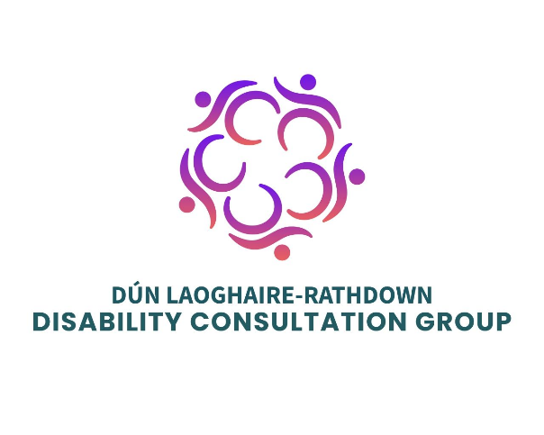

Submission of the DLR Disability Consultation Group

Review of the Disability Act 2005

1. Introduction
The Dún Laoghaire-Rathdown County Council Disability Consultation Group (DCG) welcomes the opportunity to contribute to the review of the Disability Act 2005.
The DCG is an independent advisory group made up of people with lived experience of disability, disability sector representatives and family members. It advises Dún Laoghaire-Rathdown County Council on disability, accessibility and inclusion.
This submission reflects the views and experiences shared by members at a dedicated consultation on reform of the Act. Members recognised that the Disability Act was an important step forward when introduced. However, after more than 20 years, they believe it no longer reflects modern understandings of disability, accessibility, equality and participation.
A consistent message was that identifying a need is not enough if there is no meaningful outcome. The DCG wants to see legislation that moves beyond aspirations and processes and delivers clear rights, responsibilities and practical change. People with disabilities must be central to the development, implementation and monitoring of the revised Act.

2. A Rights-Based Approach to Disability
The DCG believes the revised Act should reflect the social and human rights model of disability and align fully with the United Nations Convention on the Rights of Persons with Disabilities (UNCRPD).
Section 2 of the Disability Act 2005 places emphasis on impairment, while the UNCRPD recognises the barriers that can restrict equal participation. Members felt that modern legislation should better reflect how disability is experienced in society, including the impact of inaccessible environments, systems, services and attitudes.
The revised Act should also recognise the diversity of disability, including neurodiversity, hidden disabilities and sensory disabilities, and embed the principles of autonomy, independent living, inclusion, equality of opportunity and participation.
People with disabilities should be recognised as rights holders and active participants in society, rather than primarily as recipients of services.
The DCG recommends that the revised Act:
- Explicitly reflect the principles of the UNCRPD.
- Adopt a modern, social and human rights-based understanding of disability.
- Recognise the diversity of disability, including neurodiversity and hidden disabilities.
- Embed participation, inclusion, autonomy and equality throughout the legislation.

3. Assessment of Need and Access to Supports
Part 2 of the Disability Act established the Assessment of Need process. Members recognised its value but raised concerns about the gap between assessment and service provision.
Needs may be assessed and documented without a guarantee that the identified supports will be provided. This can leave individuals and families frustrated and can turn an important process into an administrative exercise.
The purpose of assessment should ultimately be to enable participation and improve people's lives, not simply document their needs.
The DCG recommends:
- A clearer link between identified needs and the provision of appropriate supports.
- Clear timeframes for responding to assessed needs.
- Greater accountability where identified needs are not met.
- Accessible routes for review, complaint and redress.

4. Accessibility, Universal Design and Public Services
Accessibility should be a fundamental part of how public services, buildings, infrastructure and information are designed and delivered.
Members continue to experience physical, digital and communication barriers affecting access to public buildings, transport, information, online services and community life.
Members felt that accessibility should not depend on the goodwill, knowledge or individual approach of a particular staff member. It needs to be built into systems from the outset.
The revised Act should also reflect the importance of digital accessibility, alongside existing requirements such as the EU Web Accessibility Directive.
The DCG recommends that the revised Act:
- Embed accessibility and universal design at the earliest stages of planning, design and service development.
- Strengthen requirements for improving access to existing buildings and infrastructure.
- Require accessibility to be considered in procurement and service delivery.
- Strengthen digital accessibility and proactively identify and remove barriers.
- Review qualifying provisions, including cost-related limitations, where they prevent meaningful access.
- Ensure heritage considerations are balanced with accessibility so disabled people are not excluded from cultural and historic sites.

5. Participation and Involvement of People with Disabilities
The DCG strongly supports the principle of “nothing about us without us.”
Article 4(3) of the UNCRPD emphasises the importance of closely consulting with and actively involving people with disabilities in decisions that affect them.
Members noted that consultation can sometimes happen too late, after decisions have effectively been made or barriers have already emerged. This can result in people being asked to identify solutions to problems that could have been avoided through earlier involvement.
Consultation should therefore be early, accessible and meaningful, and the information gathered should have appropriate influence on decision-making.
The DCG recommends that the revised Act:
- Require the involvement of people with disabilities in relevant policy, service and infrastructure development and monitoring.
- Ensure consultation is accessible, timely and properly supported.
- Require public bodies to explain how consultation informed decisions and provide feedback on outcomes.

6. Access Officers and Accountability
Members highlighted significant inconsistency in the role and position of Access Officers.
While the Disability Act provides for Access Officers, members felt there is insufficient consistency in their competencies, authority, resources and organisational influence.
The effectiveness of an Access Officer should not depend on where a person lives or the individual post-holder's level of influence. There should be a consistent standard across public bodies.
More broadly, members felt that rights and duties are weakened when accountability and routes to redress are unclear or difficult to use.
The DCG recommends that the revised Act:
- Set clear national expectations for Access Officer competencies, training, authority and resources.
- Ensure Access Officers have sufficient influence to contribute to decisions affecting accessibility.
- Strengthen monitoring and accountability for accessibility outcomes.
- Provide clear and accessible complaints, review and redress mechanisms.

7. Employment and Economic Participation
Part 5 of the Disability Act addresses public-sector employment targets. Members felt that disability inclusion in employment needs to go beyond recruitment quotas.
Barriers can arise throughout the employment journey, including recruitment, workplace adjustments, retention, career development and progression.
Members also highlighted that a person may be willing and qualified to work but unable to take up or remain in employment when essential supports are unavailable.
The DCG recommends that the revised Act:
- Move beyond quotas towards meaningful employment participation.
- Promote accessible recruitment and appropriate workplace accommodations.
- Improve disability awareness among employers and recruitment panels.
- Support retention, career development and progression.
- Strengthen disability inclusion across both public- and private-sector employment.

8. Disability as a Cross-Government Responsibility
Members highlighted that disability supports are often treated primarily as health issues, despite being essential to participation in education, employment and community life.
Supports such as personal assistance can determine whether a person is able to participate in many areas of society. Disability should therefore not be viewed solely through a health lens.
The DCG recommends a whole-of-government approach, with clear responsibility for considering disability and accessibility across areas such as housing, education, transport, sport, culture and employment.

9. Awareness and Attitudinal Change
Members identified disability awareness as an important part of lasting change.
Lack of understanding or confidence can contribute to inaccessible practices, even where exclusion is not intentional. Members reflected that when people understand why an adjustment is needed, they are often more willing to adapt their practices.
Education and awareness should complement, rather than replace, clear rights and accessibility requirements.

The DCG recommends:
- A stronger commitment to disability awareness across society.
- Greater disability awareness among public service providers, employers and service providers.
- Age-appropriate disability awareness education in primary and second-level education.

Key Priorities of the DCG
Priority | What the DCG believes should change
Rights-based approach | Modernise the understanding of disability and reflect the principles of the UNCRPD.
Assessment of Need | Connect identified needs to meaningful supports, with clear timeframes and accountability.
Accessibility & Universal Design | Build accessibility into buildings, infrastructure, services, procurement and information from the outset.
Participation | Involve people with disabilities early and meaningfully, and show how their views informed decisions.
Access Officers | Set consistent expectations for competencies, authority, resources and organisational influence.
Accountability & Redress | Provide clear routes to raise concerns, seek review and secure meaningful outcomes.
Employment | Support inclusive recruitment, workplace adjustments, retention and career progression, rather than focusing on quotas alone.
Cross-government responsibility | Make disability inclusion a shared responsibility across public policy and services.
Awareness & Education | Promote disability awareness across society, including through education.

Conclusion
The DCG believes the review of the Disability Act is an important opportunity to create legislation that reflects the lives and experiences of disabled people today.
The central message from members is simple: rights must translate into real access, participation and opportunity.
A revised Act should recognise disabled people as rights holders, remove barriers rather than place responsibility on individuals to overcome them, and ensure that their voices are central to decisions affecting their lives.
The DCG recommends that the revised legislation be grounded in lived experience, aligned with the UNCRPD and supported by clear responsibilities, meaningful accountability and outcomes that improve everyday life.

