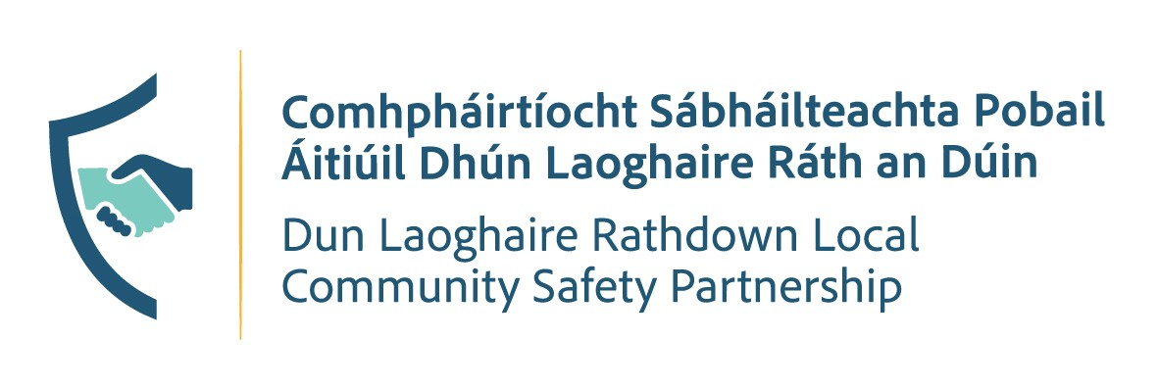
PUBLIC MEETING
📅 Tuesday, 3rd November, 2026
📍 Talbot Hotel, Stillorgan
Schedule
🕔 5:00 PM
DLR LCSP Committee Meeting
Followed by
🕖 7:00 PM
Public Meeting

Have Your Say
Join us at the Public Meeting to discuss local community safety priorities and contribute your views on issues affecting the area.
All members of the public are welcome to attend.

📍 Venue: Talbot Hotel, Stillorgan
📅 Date: Tuesday, 3rd November, 2026
⏰ Times: 5:00 PM & 7:00 PM
