Glenamuck District Roads Scheme – July 2026 Update
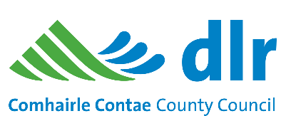

The Glenamuck District Road Scheme involves building a new 1.5km road (GDDR) running roughly parallel to the existing Glenamuck Road, and another new 1.8km road (GLDR) which runs roughly parallel to the existing Enniskerry Road. The project also upgrades part of the existing Glenamuck Road and introduces a bus gate at its junction with the GLDR. A map of the overall scheme is available at this link: https://www.dlrcoco.ie/capital-programme/glenamuck-district-roads-scheme.

Official opening
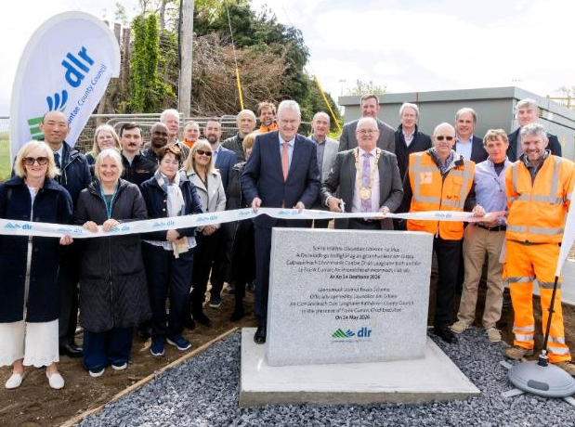

The GLDR was opened to traffic on the 7th May and the official opening of the Glenamuck District Roads Scheme took place on the 14th May 2026 by the Cathaoirleach Jim Gildea and CEO Frank Curran.

Remaining works – Golden Ball junction
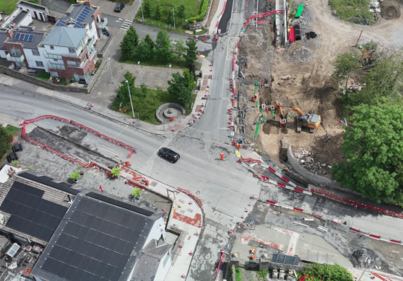
Works at the Golden Ball are nearing completion. These involve road re-surfacing, upgrade of the footpaths and provision of cycle facilities at the junction and creating an inlay bus stop. These works, as well as the works on Glenamuck Road between the GLDR and Golden Ball will be completed in early August 2026.

Bus gate on Enniskerry Road / Southern Tie-in
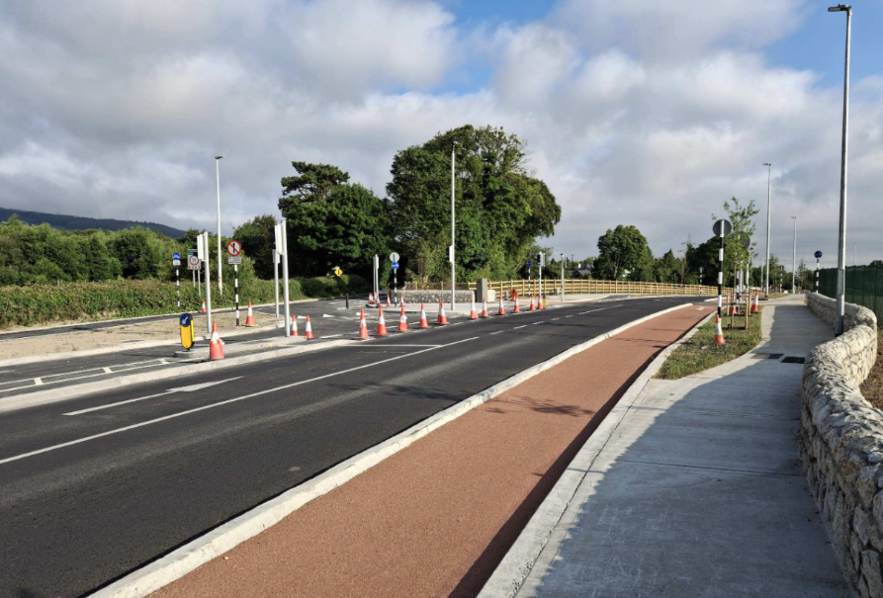
Surfacing of the bus gate at the southern tie-in of the GLDR with the Enniskerry Road is complete. Signage will be complete in the coming weeks.
Once open, buses and bicycles can use this route to access Kilternan village. Vehicular access to and from Kilternan village will be via Ballycorus Road and the GLDR only.

Bus gate on Glenamuck Road
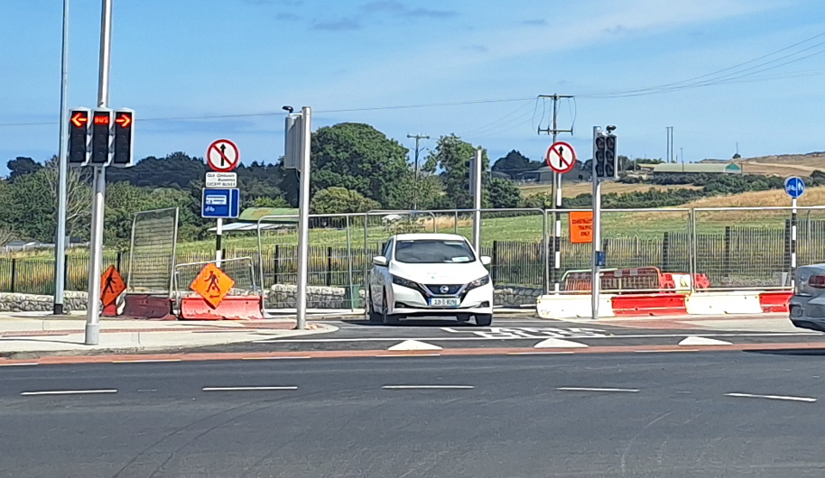
The bus gate on Glenamuck Road is complete and will open for the L26 bus route when the Glenamuck Road West opens.

Glenamuck Park
Contracted works in the park are generally complete including fencing, tree planting, hedging and grass seeding. Lighting will be installed in the coming weeks. A contract to complete further works for the park will be awarded in the near future.

We thank you for your patience and cooperation over the past two years. Please direct any queries to Pat O’Sullivan (BAM Public Liaison Officer) on 086 8584861.

