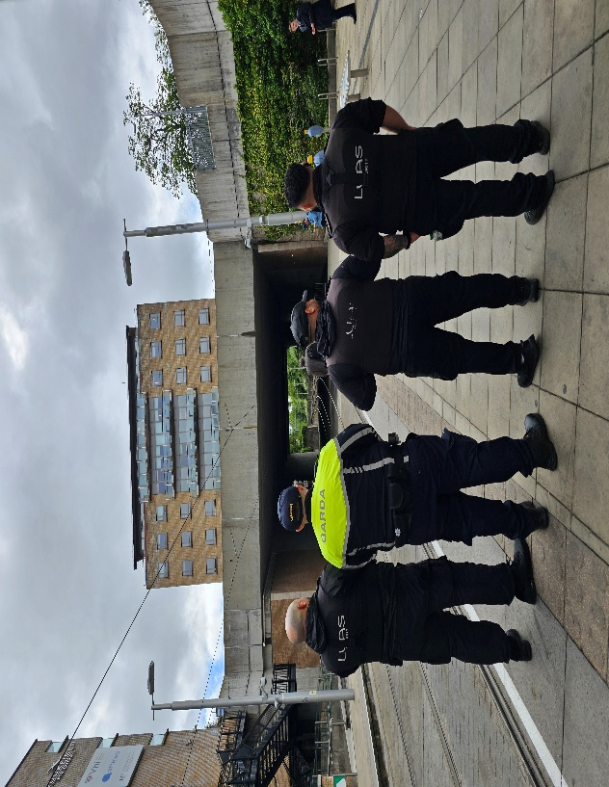

“Gardaí in Dundrum Garda Station have commenced a high visibility operation on the LUAS in the Dún Laoghaire Rathdown area.

These uniform patrols will be carried out by local Gardaí who will engage with the public, LUAS staff and provide reassurance to commuters and the public on the transport network.

They will also have an enforcement function and while the operation only commenced on June the 2nd there has already been detections in this regard.”

