Notification of Car Park Works
Dear Resident/Business Owner,

Please see outline below, of works due to commence on Tuesday February 3rd 2026 in the Sandyford Road Carpark, Dundrum.

Richard Nolan Civil Engineering are undertaking the works on behalf of Dún Laoghaire – Rathdown County Council and the NTA. These works include the improvement of the facilities within the carpark as part of the Safe Routes to School (SRTS) Programme. These works will deliver improved pedestrian routes, tree planting, improved parking facilities as well as new drainage and resurfacing of areas within the car park. These works are anticipated to take 9 weeks from the start date mentioned above. A traffic management system will be in place, resulting in the temporary suspension of the parking spaces highlighted in red per the traffic management plan below:

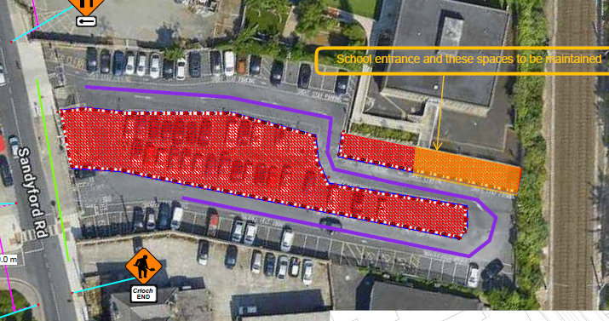

Please note: There will be no long term/all-day parking during the duration of the works. There will only be short stay parking available.

Access to the carpark and the adjacent Holy Cross NS will be maintained at all times.

We would greatly appreciate your co-operation and patience during these essential works.

Richard Nolan Civil Engineering would like to apologise in advance for any inconvenience caused as a result
of the works. If we may be of any assistance or you have any queries regarding the works, please don’t hesitate to contact us at any time either on site or by contacting the numbers below.
Richard Nolan Civil Engineering Ltd 086 832 2420 RNCE Project Manager
DLR County Council contact - info@dlrcoco.ie DLR County Council

Kind Regards
Richard Nolan Civil Engineering

