GENDER PAY GAP REPORT 2025

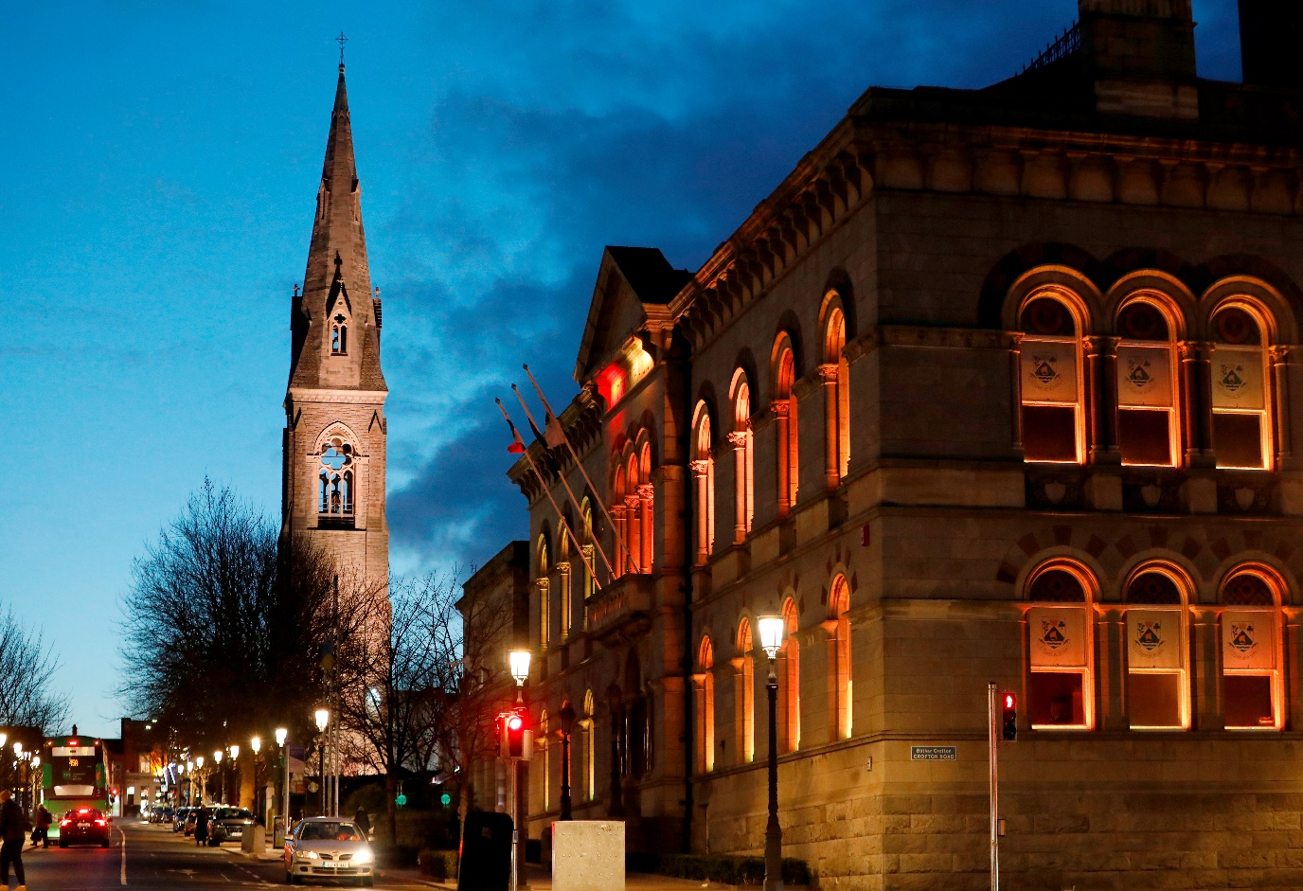

Contents

- Introduction ……………………………………………………………………………………… 1

- About us ………………………………………………………………………………………… 2
- Local Government in Ireland
- Dún Laoghaire-Rathdown County Council …………………………………………. 3

- Gender Pay Gap Reporting …………………………………………………………………. 4
- Gender Pay Gap Reporting 2025
- Who is included?
- What do we mean by the Gender Pay Gap?
- Mean and Median Gender Pay Gaps
- Quartile Pay Bands ………………………………………………………………………… 5
- Bonus and benefit-in kind ………………………………………………………………. 6
- Factors that can have an impact on the Gender Pay Gap

- Our figures ……………………………………………………………………………………… 7
- All employees
- Part-time employees ……………………………………………………………………… 9
- Temporary employees ………………………………………………………………….... 10
- Benefit-in kind
- Bonus payments

- How we are supporting gender equality …………………………………………………... 11

- Introduction

Dun Laoghaire-Rathdown County Council is at the forefront of delivering services to our citizens. Our vision is a progressive, sustainable, inclusive and accessible county underpinned by a strong economy.

This is the fourth year of reporting on the gender pay gap and I welcome the opportunity to examine progress in this area analytically. The issue of gender pay difference is an important one, not only to the workplace but to wider society.

As Chief Executive, I am proud to say that Dún Laoghaire-Rathdown County Council is led by a gender balanced senior management staff and we have over almost 1300 employees (58% male and 42% female) including administration, professional, technical, and general services staff teams.

Our employees are at the core of our organisation. We continue to strive to promote and sustain an inclusive organisational culture which provides equality of opportunity and where every employee feels valued. Dún Laoghaire-Rathdown County Council is a place where all employees have the same opportunities for recognition and career development and are treated fairly and equitably at work.

Many equality, diversity and inclusion initiatives and supports are already in place and DLRCC employs a fulltime Equality Officer. We will continue to work in this area as improvement is always possible. We continue to be committed to addressing workplace barriers to equality, supporting diversity, and creating an open and inclusive workplace community.

We will examine what this year’s gender pay gap figures can tell us about our organisation, and this will help inform our action plans. We will also continue to work with our colleagues across the Local Authority sector to share best practice and monitor trends over time and look forward to next year’s figures.
Frank Curran, Chief Executive, Dún Laoghaire-Rathdown County Council
2. About us

Local Government in Ireland
There are 31 local authorities and 3 regional assemblies in Ireland. Local authorities are the closest and most accessible form of government to citizens. They have responsibility for the delivery of a wide range of services in their local area, with a focus on making cities, towns, villages and the countryside attractive places in which to live, work and invest. Local authority services make a significant contribution to the physical, cultural, social and environmental development of communities and include housing, planning, infrastructure, environmental protection and the provision of amenities and recreation and community infrastructure.

Local authorities play a key role in promoting social inclusion and quality of life and supporting economic development and enterprise at a local level. Local authorities take the lead role in shaping the strategic vision of the county or city. They also work in partnership with other state, public and private bodies in the delivery of critical infrastructure and shared services. Local authorities deliver hundreds of services and implement policy across a range of areas including:

Arts and culture
Climate action
Community services
Economic development
Environment
Housing
Libraries
Parks and open spaces
Planning
Roads and transport
Tourism

Local authority employees come from a wide range of backgrounds with diverse skill sets, qualifications and experience. Roles in the sector include:

Accountants
Administrators
Apprenticeships
Archaeologists
Architects
Archivists
Conservation officers
Engineers
Fire services

General service and tradespeople
Graduates
Health and Safety
Information technology
Library services
Planners
Senior management roles
Technicians

Working for Dún Laoghaire-Rathdown County Council gives our employees the opportunity to gain experience at the heart of local government and to make a real difference for Dún Laoghaire-Rathdown. Everything we do in Dún Laoghaire-Rathdown County Council is geared towards making Dún Laoghaire-Rathdown a great place to live and work and our employees play a vital role in that ambition.

Dún Laoghaire-Rathdown County Council
Located between the mountains and the sea with superb transport links and a necklace of small villages on our doorstep, Dún Laoghaire-Rathdown County Council provides a wide range of services to citizens, businesses, and visitors to the County.

Dún Laoghaire-Rathdown County Council employs a workforce of almost 1300 employees. As an organisation, Dún Laoghaire-Rathdown County Council seeks to enhance the county’s attraction as a place in which to invest, work, and live, and takes the lead role in shaping the strategic vision of the county. We provide a diverse, multi-layered, and evolving range of services to both citizens and visitors to the County, which include the provision of housing, planning, development, environmental, roads and traffic, leisure, and community services.

At Dún Laoghaire-Rathdown County Council our people are our strength, and our employees work in a dynamic and progressive environment which promotes learning and development, digital excellence, work life balance and flexible working practises.

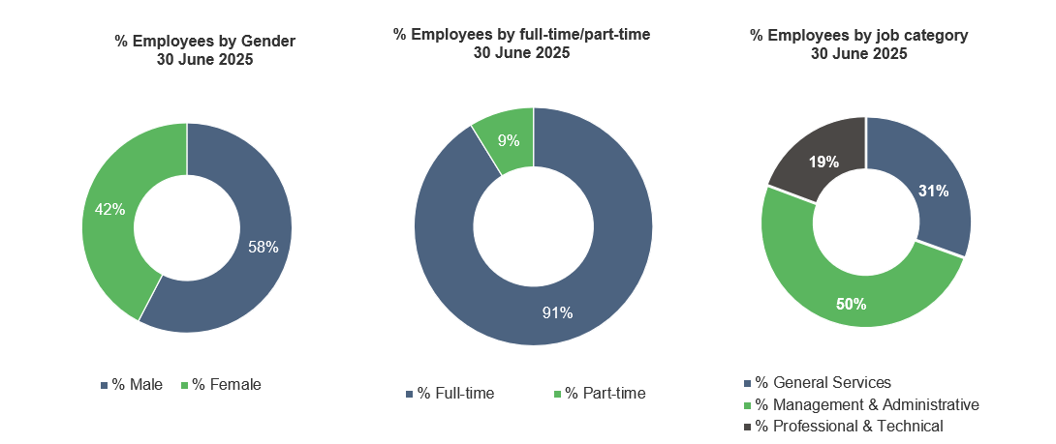

3. Gender Pay Gap Reporting

Gender pay gap reporting 2025.
The Gender Pay Gap Information Act, 2021 requires organisations with over 250 employees to report on their Gender Pay Gap. 2025 is the fourth year that organisations will have to report on their Gender Pay Gap. Organisations are asked to select a ‘snapshot’ date in the month of June. The reporting period is the 12-month period immediately preceding and including the snapshot date. For local authorities this is 30 June 2025. Organisations have five months to prepare their calculations, before reporting five months later during November 2025. The information must be published on the employer’s website or in some other way that is accessible to all its employees and to the public.

Who is included?
All persons employed by the employer on the snapshot date, including employees not rostered to work on that date and employees on leave. The mean and median figures must also be given separately for part-time and temporary employees.

What do we mean by the gender pay gap?
The Gender Pay Gap calculates the percentage difference between the average earnings of males and females irrespective of their role. The Gender Pay Gap is not the same as equal pay. Employment Equality legislation provides for equal pay for like work. All male and female employees in the local government sector are paid equally for work that is the same or similar or for work of equal value, therefore this report does not examine equal pay. Rates of pay within the sector are agreed through national wage agreements negotiated regularly between employers and staff representatives. Most employees are paid according to an incremental salary scale and the salary ranges for various roles are available on the local government jobs website at www.localgovernmentjobs.ie

Mean and Median Gender Pay Gap
The Gender Pay Gap calculates the percentage difference between the average earnings of males and females irrespective of their role, using the following measures:

MEAN GENDER PAY GAP
This shows the % difference between the
average hourly rate of pay for males
and
average hourly rate of pay for females

(average male hourly rate) – (average female hourly rate) x 100
average male hourly rate

MEDIAN GENDER PAY GAP
This shows the % difference between the
median hourly rate of pay for males
and
median hourly rate of pay for females

(median of male hourly rates) – (median of female hourly rates) x 100
median of male hourly rates

The mean is the average. It is calculated by getting the difference between the average hourly rate of pay for males and the average hourly rate of pay for females (male hourly rate minus female hourly rate), expressed as a percentage of the male hourly rate. If this figure is negative, the average hourly rate of females is higher than the average hourly rate of males on the snapshot date. If this figure is positive, the average hourly rate of males is higher than the average hourly rate of females on the snapshot date.

The median is the figure that falls in the middle of a range where the salary of all relevant employees is listed, from the lowest to the highest. This can provide a more accurate representation of the ‘typical’ differences in pay.

It is useful to look at both the mean and median figures, as each one can tell us something different about the underlying factors affecting the pay gap. For example, a small number of higher paid employees can impact the mean figure and if this is the case, the median figure may be more representative of difference between what a male and a female is paid. If there is a significant difference between an organisation’s mean and median pay gap, this may indicate that the data is impacted either by the presence of very low earners (making the mean lower than the median) or by a group of higher earners (making the mean higher than the median). It is also important to remember that this report uses data on a snapshot date in June. Gender pay gaps can fluctuate from month to month and across quartile pay bands, depending on changes to headcount. However, headline figures will give a good indication of the differences between average earning between males and females.

Quartile Pay Bands
Dividing employees into four more-or-less equal groups (or quartiles) with pay graded from lowest to highest helps us to examine pay across different levels of the organisation. Organisations must report on the percentage of employees who fall within the lower, lower middle, upper middle and upper quartile hourly pay bands. In order to group employees into these Quartile Pay Bands, the organisation lists all employees from lowest to highest, based on their hourly rates. The employees are then divided into four equal groups or Quartiles based on this - lower, lower middle, upper middle and upper. The employer then shows the proportion of male and female employees in each quartile as a percentage e.g. percentage of male employees in the lower quartile and percentage of female employees in the lower quartile (and so on).
Bonus and benefit-in-kind
Figures must also be provided for bonus payments or benefit-in-kind payments if these apply. Bonus payments do not apply within the local government sector.
Benefit in Kind may arise in certain circumstances, such as where some professional fees are paid by the employer.

Factors that can have an impact on the gender pay gap
As mentioned, this report does not look at equal pay. Every employee, regardless of gender is paid equally for work that is the same or similar or for work of equal value. However, differences between what employees are paid can be impacted by a number of complex factors including:

- Occupational segregation – some job categories or occupations may have traditionally attracted more females than males or vice versa.
- Working patterns – full-time and part-time work. It may be that more females than males seek part-time work or career breaks and although this does not impact on their hourly rate of pay, it may impact on choices around career progression.
- Length of service – incremental pay increases may mean that new joiners are paid less than more experienced employees.
- Time of year – temporary or seasonal workers may be recruited for different roles which may attract a different rate of pay.
- Gender breakdown of senior roles at higher salaries – a small number of higher paid employees can affect the average figures.
- Gender breakdown of lower paid roles – a large number of lower paid employees can affect the average figures.

If an organisation reports a positive gender pay gap, it does not mean that females are paid less than males for doing the same job, but it does show that, on average, males occupy higher paid roles than females.

If an organisation reports a negative gender pay gap, it does not mean that males are paid less than females for doing the same job, but it does indicate that, on average, females occupy higher paid roles than males.

The larger the positive or negative pay gap is, the more marked the differences in hourly rates of pay will be and the more males or females proportionally working in either higher or lower paid roles within the organisation.

4. Our Figures

Mean and Median Gender Pay Gap - all employees

Dún Laoghaire-Rathdown County Council Gender pay gap 2025
All employees for the reporting period to 30 June 2025
MEAN GENDER PAY GAP | MEDIAN GENDER PAY GAP
-2.37% | -13.21%

Note: 58% male / 42% female is the gender breakdown of all employees on 30 June 2025. This is shown in the dotted line above.

The Mean Gender Pay Gap shows that on average, females are paid 2.37% more than males. The Median Gender Pay Gap shows that the median rate of pay for females is 13.21% higher than the median rate of pay for males.

For comparison purposes the Mean Gender Pay Gap in 2024 was -2.93% and the Median Gender Pay Gap was -10.65%

Looking at the distribution of employees across the four Quartile Pay Bands helps us examine pay at different levels of the organisation.

These Quartile Pay Bands show the distribution of male and female employees by Pay Band across the organisation listed from lowest to highest, based on hourly rates and then divided into four equal Pay Bands or Quartiles – lower, lower middle, upper middle and upper. The proportion of male and female employees are then shown in each quartile.

In DLRCC 31% of our total staff are in the general service category, 50% are in the clerical & administrative and managerial categories and 19% are in the professional & technical category.

The split for quartile 1 above shows that there are almost equal numbers of male and female employees in the lowest paid quartile with 54% male and 46% female.

Further analysis of the job categories in this quartile confirms that 61% of staff in this quartile are outdoor staff. 58% of the outdoor staff in this quartile are male and 42% are female. This category includes our school wardens. The balance of the quartile comprises 38% clerical & admin staff.

Quartile 2 contains a substantially higher percentage of males than females with 69% males and 31% females. This quartile comprises 49% outdoor staff, 40% clerical & administrative staff and 11% professional & technical staff 96% of the outdoor staff are male and 59% of the clerical & administrative staff are male.

Quartile 3 is split 52% male and 48% female with the quartile 4 composition at 55% male and 45% female.

Clerical & Admin staff represent 71% of quartile 3, 17% are professional & technical and 12% are outdoor staff.

Gender analysis of each job category shows the following breakdown over the organisation as a whole:
- Outdoor staff 24% male and 7% female (31% of all staff)
- Clerical & Admin staff 21% male and 28% female (49% of all staff)
- Professional & Technical staff 12% male and 7% female (19% of all staff)
- Managerial staff .6% male and .4% female (1% of all staff)

The General Services category on average has the lowest average hourly rate of pay and the highest percentage of males per category at 77%. This reflects the fact that there are proportionately more males at lower paid grades.

Mean and Median Gender Pay Gap - Part-time employees

Dún Laoghaire-Rathdown County Council Gender pay gap 2025
Part-time employees for the reporting period to 30 June 2025
MEAN GENDER PAY GAP | MEDIAN GENDER PAY GAP
-25.88% | -45.69%

Approximately 9% of all our employees on 30 June were working part-time. Of these,39% are male and 61% are female.

Factors influencing the pattern of part-time employees across the organisation include a range of flexible work options for part-time work, which, while available to all employees, have a greater take-up in administrative and clerical job categories.

Another factor is job categories where part-time work is an occupational feature of the role including e.g. school wardens.

48% of part time employees on 30th June were clerical & administration staff, 47% were outdoor staff and 5% were professional & technical staff.
83% of clerical & administration staff were female and 17% were male. 39% of outdoor staff were female and 61% were male. 67% of professional & technical staff were female and 33% were male.

51% of employees in quartile 1 were female and 49% were male. 44% of employees in quartile 2 were female and 56% were male. 81% of employees in quartile 3 were female and 19% were male. 87% of employees were female and 13% were male.

A high percentage of female part time employees on 30th June in quartile 3 & quartile 4 (81% and 87% respectively), has resulted in a mean gender pay gap showing that on average part time female employees were paid 25% more than part time male employees.

The 2025 Gender Pay Gap report also includes temporary part-time employees in this category.

Mean and Median Gender Pay Gap - Temporary employees

Dún Laoghaire-Rathdown County Council Gender pay gap 2025
Temporary employees for the reporting period to 30 June 2025
MEAN GENDER PAY GAP | MEDIAN GENDER PAY GAP
14.39% | 2.52%

On 30 June 2025, 8% of our employees were employed on temporary contracts. Of these, 50%, are female and 50% are male. These contracts include temporary/seasonal employees such as lifeguards, temporary school wardens, temporary general operatives, as well as graduates and students and also staff on non-seasonal temporary contracts.
45% of staff in quartile 1 were male, 55% of staff in quartile 2 were male, there were no males in quartile 3 and 82% of staff in quartile 4 were male.
45% of temporary employees on 30th June were outdoor staff, 25% were clerical & administration, 29% were professional & technical and 1% were management.

The proportionately higher number of temporary males than temporary females in quartile 2 alongside the 82% males in quartile 4 where pay rates are highest has resulted in a mean gender pay gap on 30th June which shows that on average temporary male employees were paid 14% higher than temporary female employees.

Benefit in kind
On 30 June 2025 .81% of male employees had received a Benefit in Kind payment and .18% of females had received a Benefit in Kind payment.

Bonus payment
Bonus payments do not feature as part of pay in the local government sector.
5. How we are supporting Gender Equality

Fair and transparent Recruitment practices
As an equal opportunities’ employer, we work to promote a culture of equality, and we strive to embrace genuine equality of opportunity through our recruitment and selection processes which are open to all.
We provide appropriate assistance and accommodation throughout our recruitment and selection processes, including providing easily accessible interview facilities, agreeing an appropriately timed interview, and supplying or arranging appropriate equipment.

All our Interview Boards are gender balanced and receive training, including unconscious bias training.

We offer our new recruits a range of family friendly and flexible working options, and our job descriptions and job advertisements are gender neutral.

We provide training and support, open to all employees to help them prepare for job applications and interviews.

Employees are paid according to an incremental salary scale, and we offer strong career progression opportunities which are open to all employees.

Work life balance
We offer a wide range of flexible working and leave options which are available to all employees, including carer’s leave, career breaks, paid maternity, and adoptive leave, paid paternity leave, parent’s leave, parental leave, shorter working year schemes, work-sharing.

Blended working
Blended working is now a part of our flexible working policies with flexible options to combine on-site and remote working.

We provide access to the Cycle to Work Scheme and the Tax Saver Scheme, to reduce commuting costs.

Learning and development
We are committed to providing ongoing learning and development opportunities so that all employees can develop to their full potential. All employees are actively encouraged to pursue education opportunities through the Education Assistance Scheme, with study and examination leave also available.

Health and Wellbeing
The health and wellbeing of all employees is paramount, and a healthy work-life balance is important to us in. We offer comprehensive employee occupational health and wellbeing programmes including an Employee Assistance Programme, health screening, health and nutrition advice and wellbeing webinars etc.

We have developed an inclusive employee App to ensure that all our employees can be communicated with regularly and to promote wellbeing initiatives.

Dignity at Work
We promote and support a culture of dignity, respect, and equality. We have a Dignity at Work Policy and all employees and managers have received training and support in the implementation of the policy.

Equality, Diversity and Inclusion
Dún Laoghaire-Rathdown County Council is continually developing as an employer of choice to attract, develop and promote an inclusive and diverse employee population.

Dún Laoghaire-Rathdown County Council employs a fulltime Equality Officer and continues to design and provide responsive services and customer care that meet the needs of an increasingly diverse customer base.

Dún Laoghaire-Rathdown County Council progressively embeds the Public Sector Duty in its current management, policy development and service delivery processes.

An assessment has been conducted of equality and human rights across Council functions and services and the Council has developed an Implementation Plan on equality and human rights.

Human rights and equality statement has been incorporated into the Council’s corporate plans and strategic plans.

Public Sector Duty
Dún Laoghaire-Rathdown County Council progressively embeds the Public Sector Duty in its current management, policy development and service delivery processes.

The Public Sector Duty is set out in Section 42 of the Irish Human Rights and Equality Commission Act, 2014. Section 42 requires a public body, in the performance of its functions, to have regard to the need to eliminate discrimination, promote equality of opportunity and treatment of its staff and the persons to whom it provides services and protect human rights of its members, staff and the persons to whom it provides services.

Public bodies are required to set out in a manner that is accessible to the public in its strategic plan an assessment of the human rights and equality issues it believes to be relevant to its functions and purpose and the existing or proposed policies, plans and actions to address those issues. Furthermore, public bodies are required to report annually on developments and achievements in that regard in its annual report in a manner that is accessible to the public.

Dún Laoghaire-Rathdown County Council acknowledges the commonality of purpose stated in both the “Duty” and Gender Pay Gap reporting requirements and the publication of this report serves to underline and support the three-step approach advocated by the IHREC i.e., Assess, Address and Report.

Women in leadership
Our Senior Management Team comprises the following gender balance 60% Male and 40% Female and we continue to support our staff through Women in Leadership programmes.

Apprenticeships
As part our inclusive approach to recruitment, Dún Laoghaire-Rathdown County Council offers a number of apprenticeship programme and participates as part of the Department of Further and Higher Education, Innovation and Science’s Action Plan for Apprenticeship 2021 – 2021 which aims to increase the number of apprenticeships within the Public Service..

Data collection and evidence-based policy development
We welcome the opportunity to report on our gender pay gap and have worked collaboratively across the sector to provide a standard and consistent approach to reporting. We will work with the LGMA and our colleagues in other local authorities to share learnings and best practice.

