DLR Grants Scheme Branding & Recognition Guidelines
Purpose
To ensure consistent and visible recognition of Dún Laoghaire-Rathdown County Council’s support across all promotional materials created by dlr grant recipients.
1. Branding Statement
All promotional materials must include the logo:
“Co-funded by DLR logo”
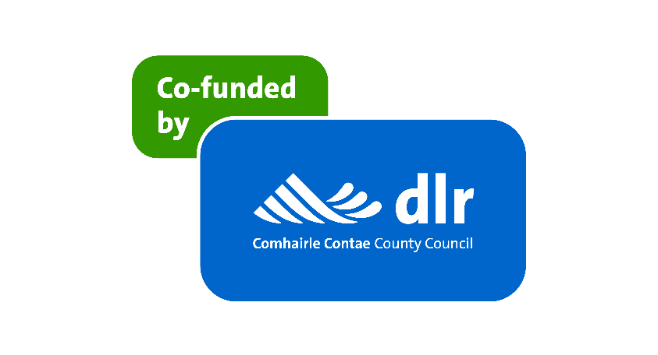
2. Logo Usage
- Use the official supported by DLR logo (available in colour and monochrome versions).
- The logo must be clearly visible and not distorted, cropped, or altered.
- Minimum size: 20mm width for print, 150px width for digital.
- Clear space: Maintain a margin equal to the height of the “DLR” text around the logo.
Download logos on the dlr Grants webpage www.dlrcoco.ie/grants
3. Placement Guidelines
Include the logo and/or branding statement in the following locations:
Website: Footer or dedicated “Supporters” section
Social Media Posts: In caption text or as part of the image/video
Posters/Flyers: Bottom corner or alongside other funders
Event Banners: Prominent placement near title or sponsor area
Press Releases: Mention in the funding acknowledgment section
Videos: Opening or closing credits, or watermark
Newsletters: Footer or funding acknowledgment section
4. Social Media Recognition
When posting on social media, tag:
Facebook: @dlrcoco
Twitter/X: @dlrcc
Instagram: @dlrcc
Use hashtags: #DLRGrants #SupportedByDLR
5. Acknowledgment Text (Optional for Longer Formats)
For reports, brochures, or websites:
“This project/event was made possible through the support of the Dún Laoghaire-Rathdown County Council Grants Scheme.”
6. Queries
📧 communications@dlrcoco.ie
📞 01 205 4700

