Announcement details for Website/PPN/Social Media
Dún Laoghaire-Rathdown County Council
Community & Volunteer Awards 2025 Open for Nominations

Nominations are now open for this year’s Community & Volunteer Awards. Nominations can be submitted on behalf of a local group, organisation and/or an individual volunteer in your area for an award.
Please note the closing date for nominations is 20th October 2025 at 5pm.
All winners will be announced at the Community & Volunteer Awards Ceremony taking place on the 6th November 2025 in The Talbot Hotel, Stillorgan
Link to online nomination form or Scan QR Code for a Community Group or Organisation
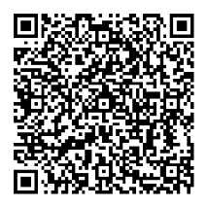
Link to online nomination form or Scan QR Code for a Volunteer
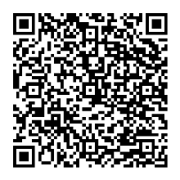

Printable Nomination Forms available upon request, please email community@dlrcoco.ie

Submit an online nomination or return completed forms by email to community@dlrcoco.ie
or by post to:
Community and Volunteer Awards, Community and Cultural Development Department,
Dún Laoghaire-Rathdown County Council, County Hall, Marine Road, Dún Laoghaire, Co Dublin, A96K6C9

