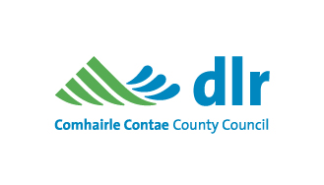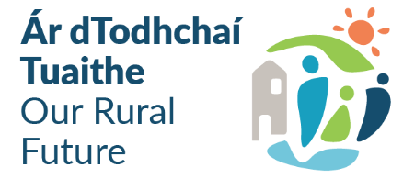

Community Recognition Fund 2024 –
dlr Funding Proposal Form, Window 3 Funding Call
This Funding Proposal Form will be assessed by Dún Laoghaire-Rathdown County Council, and we will be in contact if the application has been deemed successful for the next stage of the application process to the Department of Rural & Community Development.
Closing Date: Wednesday 15th January 2025 at 13:00
Applicant Details:

Name of Applicant Group /
Organisation / School:
Contact Person (liaison for entire
funding proposal)
Role of Contact Person:
Group / Organisation / School
address for correspondence:
Eircode:

Group / Organisation / School
Email Address:

Group / Organisation / School
Mobile phone number:
dlr Public Participation Number
(if applicable):

Main objective of Group /
Organisation / School:

Confirmation of Group /  Organisation / School  appropriate Insurance: | Yes NO

Project Details:

Project Title:
(e.g. Bally Tennis Club Resurfacing
Works)
Brief Project Description
(max 20 words)

In which area(s), prioritised for  Community Recognition Fund  2024 support by dlr County  Council, do you operate in? | Ballyogan Blackrock  Dundrum Sandyford
Project Address:
(Must be the address of were the
actual project will be situated and
include an Eircode, where possible)
Coordinates for location of
Project: (use ITM XY coordinates
with format: 123456.123 – see ITM XY
Guidelines in Appendix A)
Please outline details of the project that funding will be used for:
Please outline the identified needs in your area that this project will aim to address:

Outline how the proposed project will deliver tangible benefits to the community:
Outline the capacity of the Group / Organisation / School to deliver the project as outlined:
(Include details of track record / project
Partners / experience of delivering
similar projects)
Total Estimated Costs of project:
(Breakdown of costs and
evidence of at least 3
quotations sought and / or QS
estimate must be submitted
with this application)

Please provide a detailed outline of the proposed procurement plan for the project:
(Please include name of Procurement
Consultant / Personnel, if applicable)

Total amount of funding (€) being
applied for from Window 3, dlr
Community Recognition Fund 2024
(Min €50,000 per project & please
complete Business Case for projects
exceeding €200,000 in Appendix B)

Rate of Aid Sought
(up to a max. of 100%)
If there is a shortfall in funding
sought for this project from
overall costs, please state how
you will make up for this shortfall:

Has any element of this proposal previously been approved under any other Government Departments’ scheme? If so, please outline:

Estimated Commencement Date
(dd/mm/yyyy)
Estimated Completion Date
(dd/mm/yyyy)
(50% of the proposed project must be
completed by October 2025 & final
project to be completed by
October 2026)
Please outline details and evidence
of any permissions / consents /
assessments / planning permission /
ownership agreement / lease
agreement etc. required and in place
in order for the proposed project to
proceed:
(If not currently in place, please specify
the estimated timeline)

Use of Data:
The information on this form will be used by the Department of Rural and Community Development for the purposes of processing the application. Further information may be sought by the Department to clarify aspects of the project proposal. The form may be shared with other Government Departments for assessment purposes. The Department may draw on broader, more specialist expertise where required, and such information as considered necessary to complete an assessment of your proposal may be shared with those experts.
The Applicant and the Department are subject to the data protection and privacy laws of Ireland and the EU, in particular the Data Protection Act 2018 and Regulation (EU) 2016/679, known as the EU General Data Protection Regulation (“GDPR”). Any personal information which you provide as part of the application process will be obtained and processed in compliance with Data Protection legislation.
The Department retains the right to disclose for the purposes of a request under the Freedom of Information Act 2014 or otherwise, in connection with the funded project(s) –
- any information supplied by the Applicant to the Department, and
- any relevant data gathered by the Department in administering grant aid to the project, except where the information is considered to be personal or commercially sensitive.

Declaration by Applicant:
This declaration must be signed by an officer authorised at a senior level within the lead applicant group / organisation / school.
I confirm that I have read and understood this document and declare that the particulars supplied in this funding proposal are true and correct and that –
• The costings are accurate and reasonable.
• All necessary permissions are in place e.g. planning permissions, ownership / lease agreements, consents etc.
• All relevant ecological survey work (if applicable) has been undertaken or will be undertaken e.g. Appropriate Assessment screen.
• There is evidence of ownership (if applicable) or the consent of the landowner.
• The project will comply with Public Procurement Guidelines.
• The project conforms to the LECP and other local or regional plans.
• No funding has been allocated for the same works from any other sources.
Proof of the above is not required at the time of application but must be available to the Department or its agents on request.
I acknowledge the information regarding the use of data set out above and give consent to the Department of Rural and Community Development for the sharing of all information, personal or otherwise, contained in this funding proposal and any attachments accompanying it, in accordance with the uses of the data and information provided above.
I declare that the information provided by me on this application form is truthful and complete. I request that consideration be given in support of the project as outlined above.

Local Community Group / Organisation / School: __________________________

Signature: _______________________________

Name in Block Capitals: __________________________

Position: _________________________________

Date: ___________________________________

APPENDIX A:

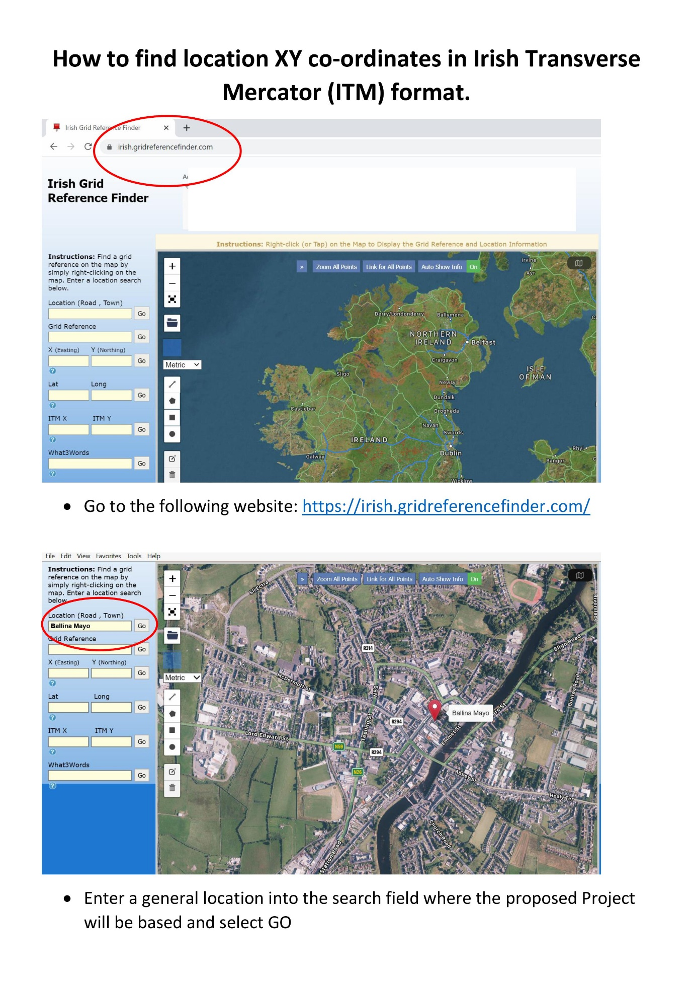

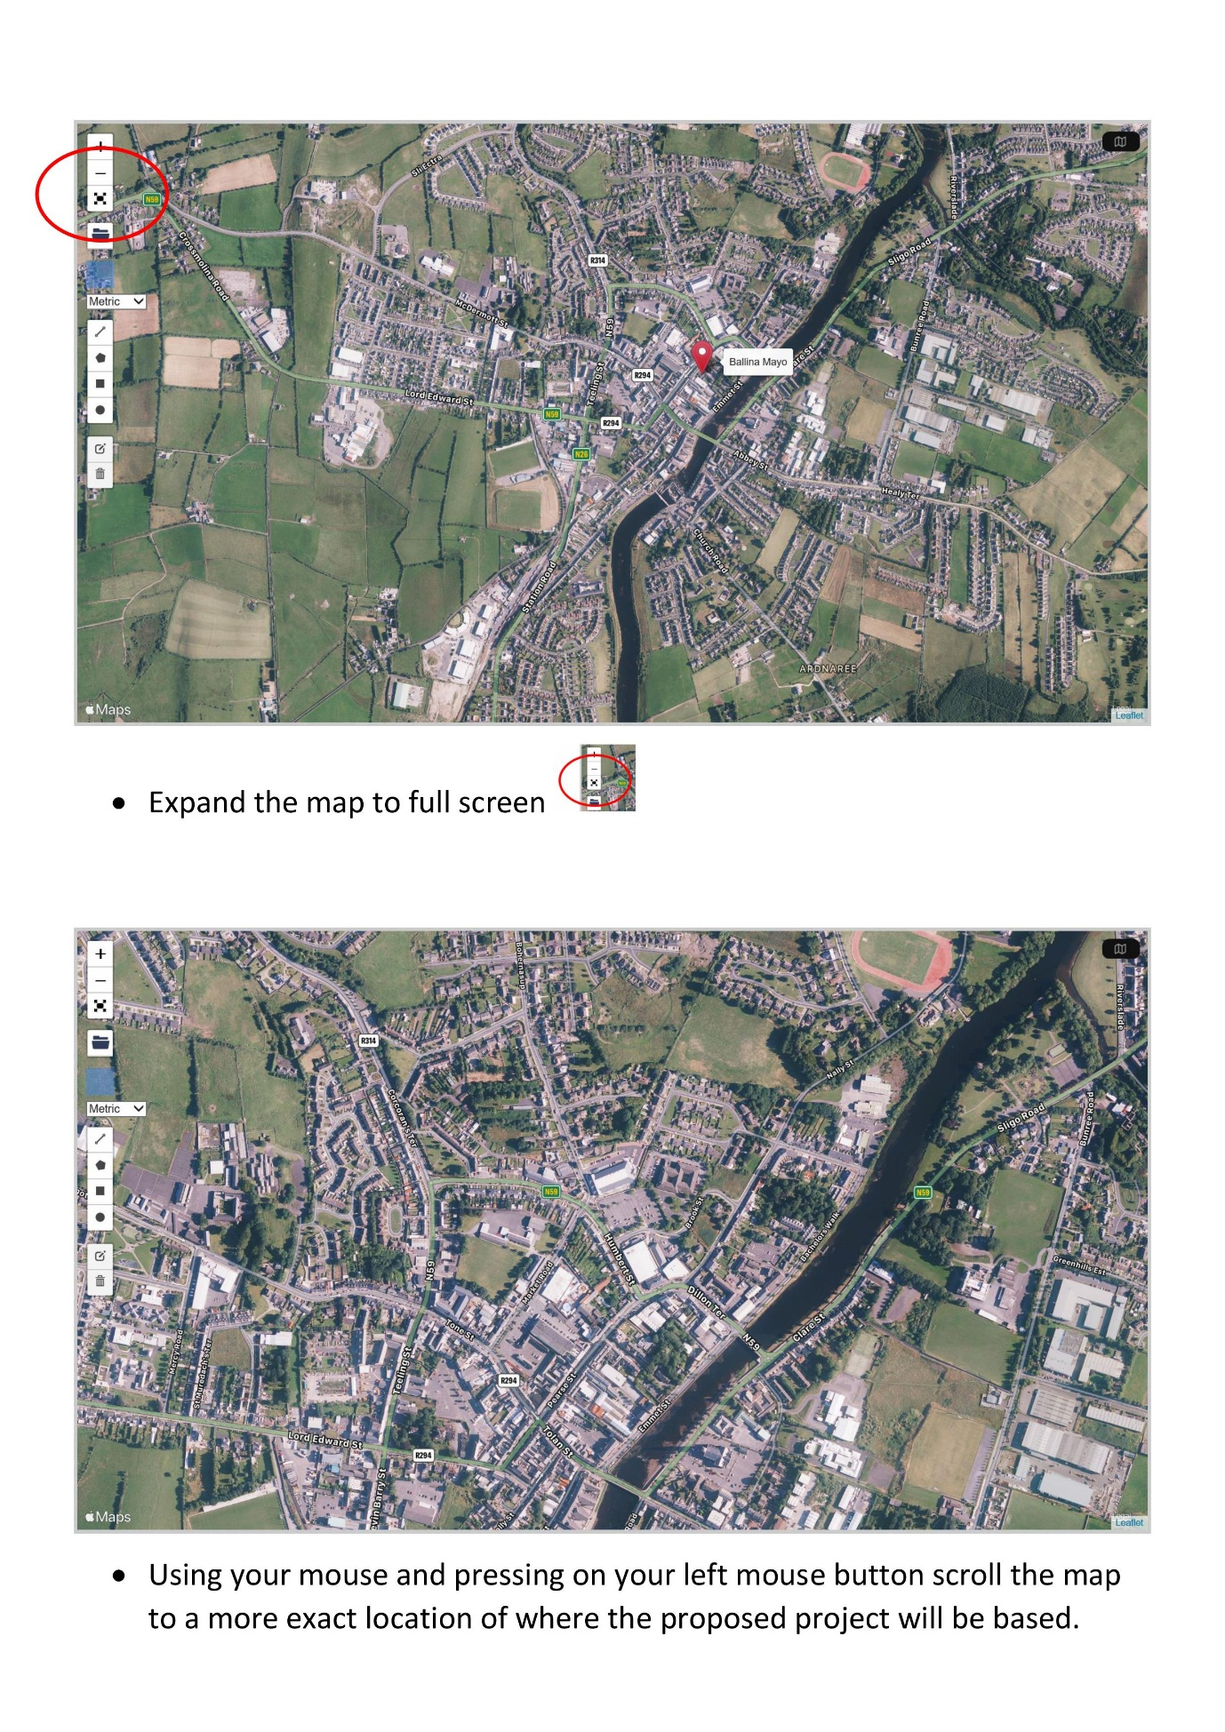

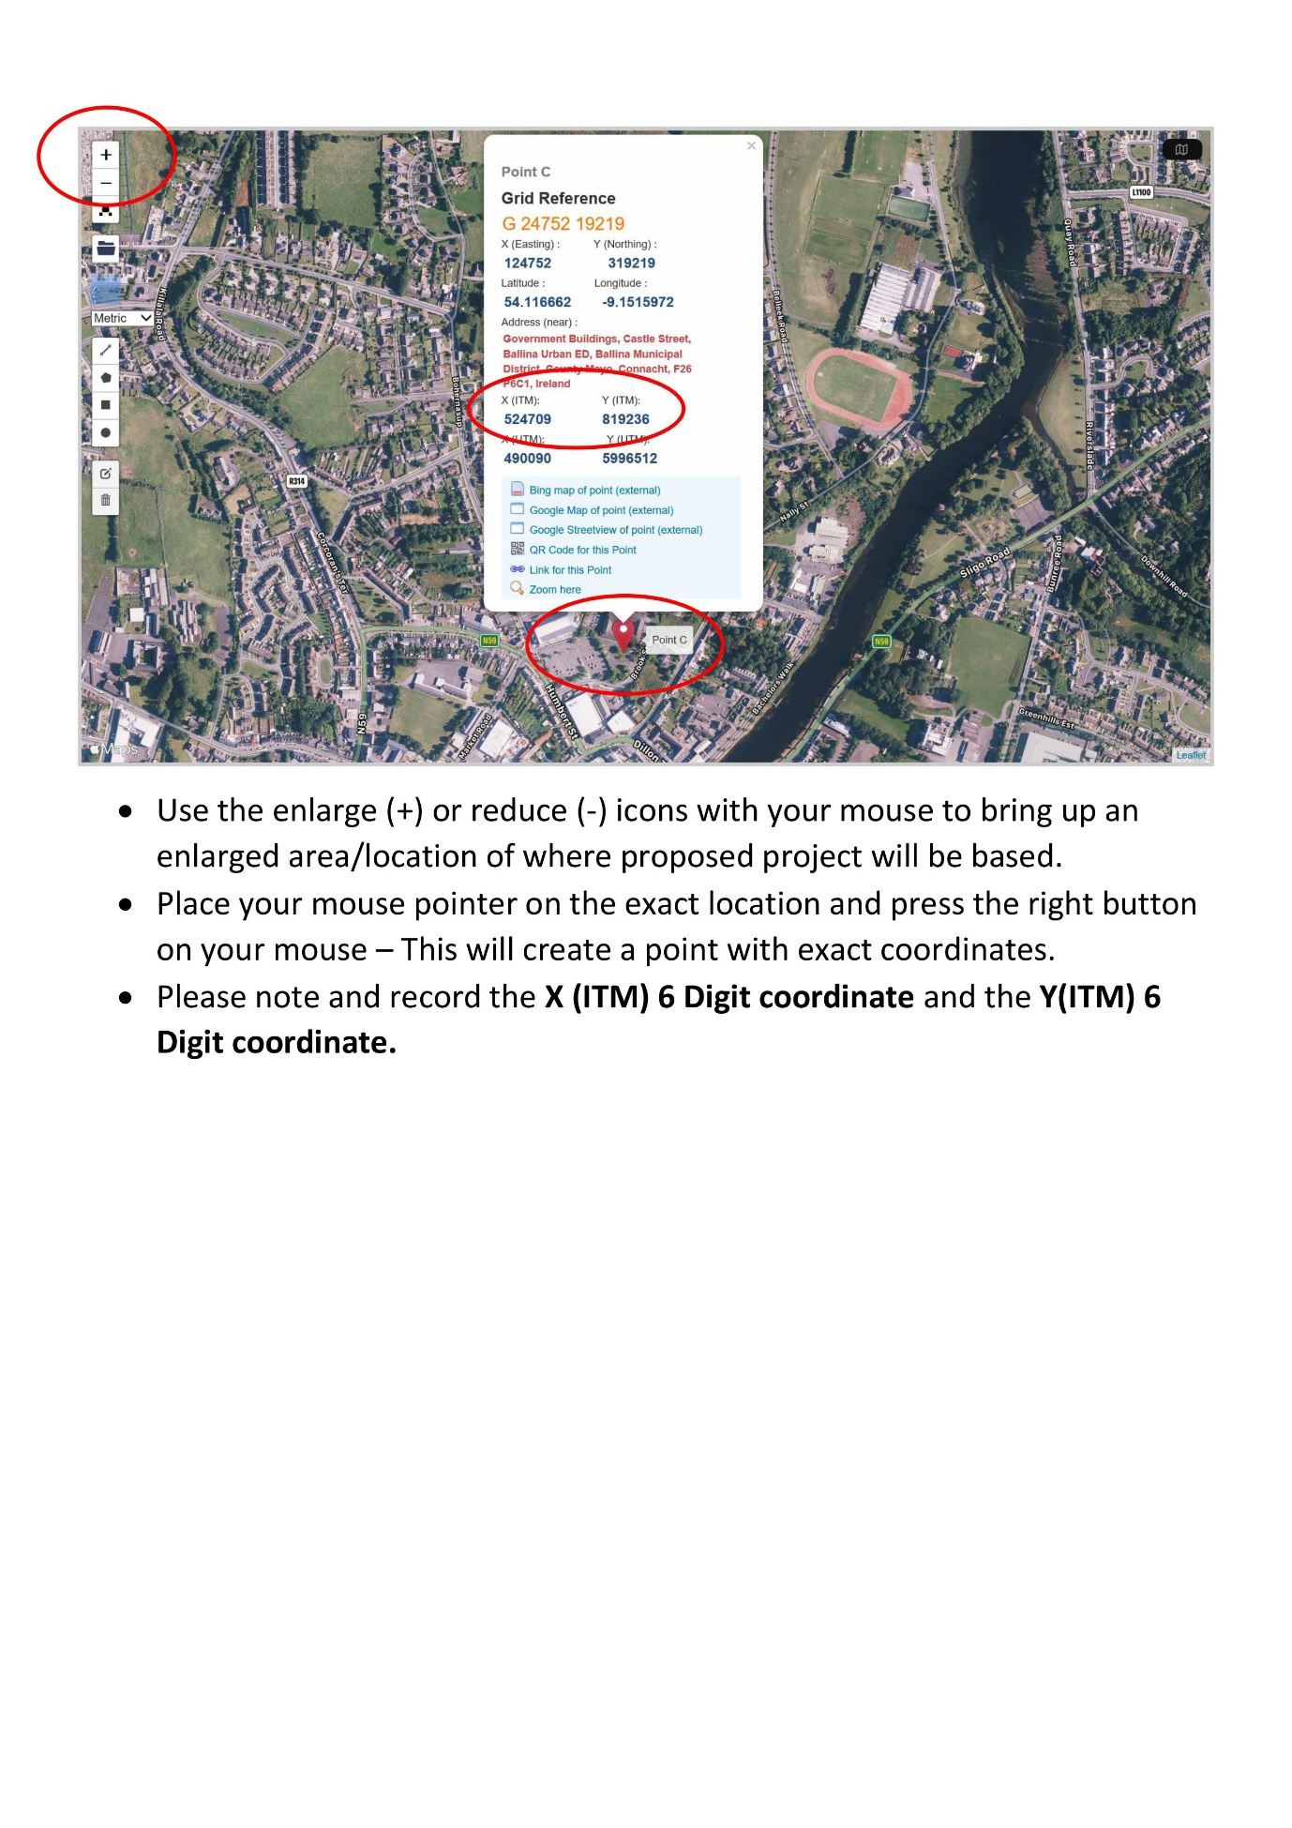

APPENDIX B:

Community Recognition Fund (CRF) 2024, Window 3 Funding call
Business case for each Project Over €200,000
Project name
City, town or village name
Summary of the proposal
Project rationale & rationale for selecting this location
Outline the community engagement and consultation
Outline the capacity of the group to deliver the project as outlined.
Include details of the track record of project partners and experience of delivering similar projects
Identified needs this project will aim to address

