Fiona Dowling – Storyteller in Residence 2016
Dún Laoghaire-Rathdown County Council is delighted to announce Fiona Dowling as the first Storyteller in Residence for the county.
Fiona Dowling is a storyteller, visual artist and facilitator living in Dublin. She tells stories to audiences of all ages; folktales from her French and Irish heritages as well as stories from far and wide. Since 2009, Fiona has told in schools, libraries, art centres and at festivals throughout the country. She has worked with young patients on hospital wards, put on storytelling evenings for adults with the international Storytelling ensemble 'Story-O' and collaborated with musicians and singers on original shows. From a Visual Arts background, Fiona is interested in different ways of presenting storytelling, of making people stop in their tracks to listen to a tale. Fiona will perform at the next Cape Clear International Storytelling Festival this coming September. She is currently preparing a Kamishibai show (Japanese paper theatre) that she will perform from her bicycle at the upcoming Five Lamps Arts Festival in March.

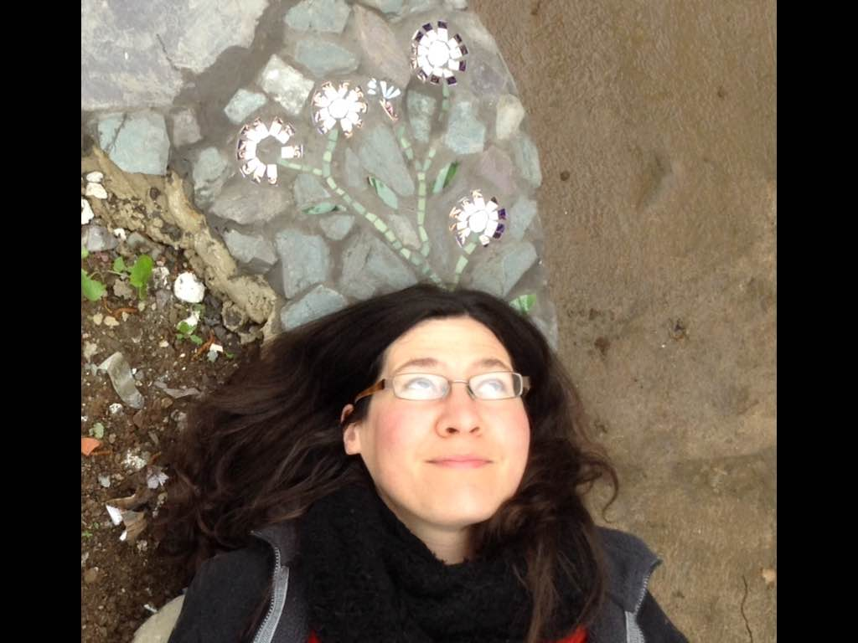

Fiona’s residency in Dún Laoghaire-Rathdown County

Fiona will be working with communities in the west of the county until October of this year finding stories from the area and developing an updated version that is a reflection of the area in 2016. She will also be creating opportunities for other storytellers as part of her residency as well as other exciting opportunities for the public to get involved. As part of her residency Fiona will be involved in a cultural exchange with Senem Donatan a professional storyteller based in Istanbul, Turkey.
The storyteller in residence is managed by Dún Laoghaire-Rathdown County Council Arts Office and is grant-aided by the Arts Council. The cultural exchange is funded through the Tandem Turkey - EU Cultural Managers Exchange Programme. It is an initiative of the European Cultural Foundation (Amsterdam), MitOst (Berlin), Anadolu Kültür (İstanbul), and supported by Stiftung Mercator (Essen).

For more information please contact the arts office (01) 2362759 or arts@dlrcoco.ie

