Dun Laoghaire-Rathdown County Council
Regional Festival & Participative Events Grant
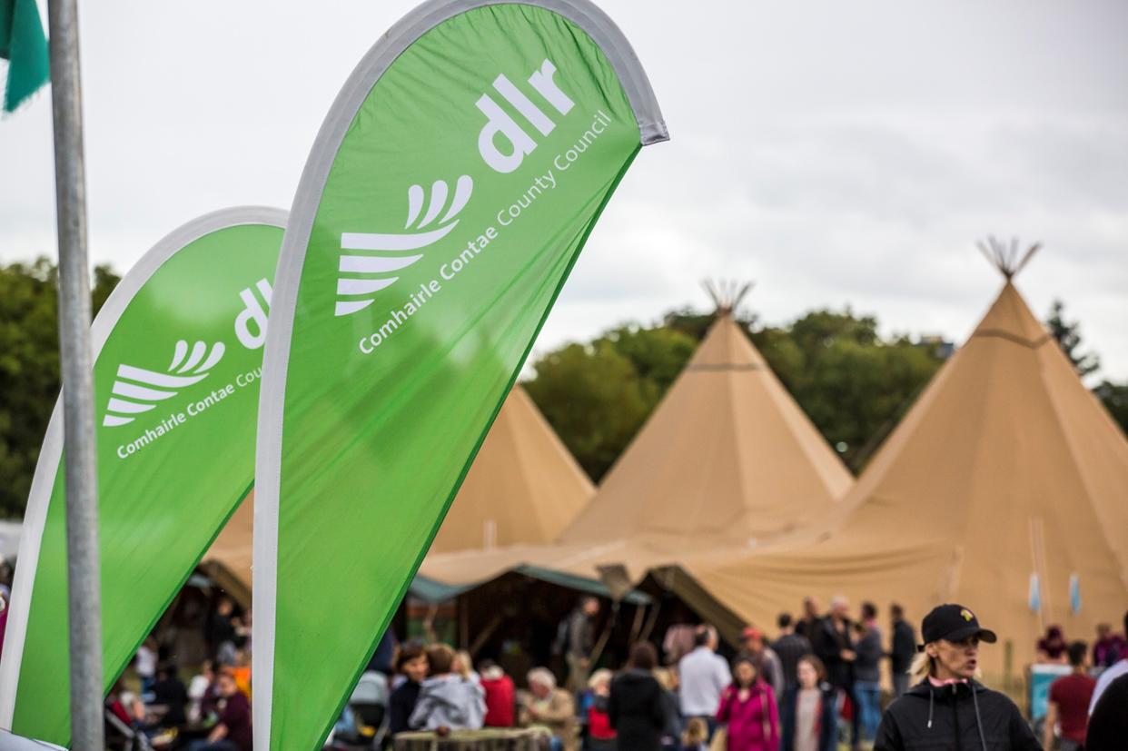
Application Form 2020
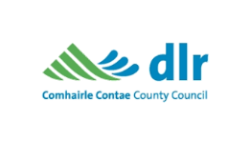
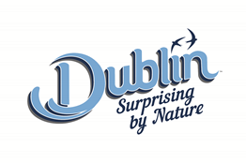

Section 1: The Applicant & Festival Details

- Applicant Details

Name of Applicant/Organisation:

Address of Applicant/Organisation:

Eircode

Applicant’s legal status:

(e.g. limited company, charity, local authority)

- Contact Person’s Details

Name:

Title:

Email address:

Telephone number:

- Festival/Event Details

Name of festival/event:

Dates of festival/event:

Location of festival/event

Is the festival new or existing?

Frequency of festival/event:

Festival/event operating since (year):

Name of company / organisation in ownership:

Festival/event office address:

- Please Provide details of proposed event/festival, outlining all elements of the proposed event/festival programme. Attach extra sheets if required.

Section 2: Marketing and Digital Capability
The purpose of this section is to give details of your marketing strategy and where relevant, sales activation. If you have prepared a marketing plan please provide a copy of it in support of your funding application.

- How will you promote the festival/event to tourists? In addressing this question, please detail (a) the target markets and (b) why these activities were chosen. (Maximum of 200 words)

The purpose of this question is to give details of your plans to make tourists aware of the festival/event digitally and to build an active on-line community.

- How does the festival/event’s on-line presence, particularly its website, generate interest among tourists? Where possible provide links to relevant digital content. (Maximum of 200 words)

- How does the festival/event utilise social media channels to generate interest among tourists. Relevant social media channels may include Facebook, Twitter, YouTube, Instagram, Snapchat, Pinterest and other platforms. (Maximum of 200 words)

Section 4: Tourism Impact
The details provided in this section will be used to establish the scale of the festival/event in terms of the likely number of tourists attending and bednights arising.

- Performance Metrics

Audience/Participant Statistics |  |  | Results for 2019 or Most Recent Year | Projections 2020 | How was data collected^
A | Attendance: | Ticketed
 |  | Non Ticketed
 |  | Total Attendance
B | Taking the total attendance figure above, please provide the following breakdown | % Local*
 |  | % Domestic*
 |  | % Overseas*
 |  | Must add to 100% | 100%
C | How many events, on average, did/will each individual attend?
D | Of those who overnight in the area, what is the average number of nights spent locally?

Notes:

*Local- Those living within a 65km/40 mile radius within the county.

*Domestic- Those living beyond a 65km/ 40 mile radius outside the county.

*Overseas – Those living outside the Republic of Ireland.

^ Please explain how the figures were estimated including what research, if any has been carried out in the compilation of the above figures.

Section 5: Delivery Team
The purpose of this section is to give Fáilte Ireland details of those who will be involved in setting up and delivering the festival/event.
- Team & Staffing

Number of Committee/Board Members:

Number of Voluntary Members:

Number of Full-Time Paid Staff:

Number of Part-Time Paid Staff:

How many volunteers will be engaged during the planning and operation of the festival/event:

What was the total salary cost for your most recent event:

- Key Team Members Provide details of the background and experience of the key individuals/companies who deliver the festival/event.

Name | Role & relevant experience

Section 6: Financial Details & Funding Requested
The purpose of this section is to establish the actual cost involved in delivering the festival/event in 2018 and the projected cost of delivering it in 2019.
In providing details:
- Enter only actual or invoiced expenditure.
- Where the applicant is in a position to recover VAT, costs should be expressed net of recoverable VAT.
- See the guidelines for details as to which costs are eligible for grant funding.
- If available, the detailed working and assumptions supporting the figures stated below should accompany this form.

- EXPENDITURE | Actual Spend 2018 | Projected Spend 2019

Marketing Costs

Development Costs

Programme & Event Production Costs

Other (please specify)
Overall Total Expenditure

- INCOME for proposed project | Actual 2018 | Projected 2019

Earned Income

Sponsorship (please specify the funder)

Grants From:

Fáilte Ireland

Arts Council

Dun Laoghaire-Rathdown County Council

Leader / Local Development Companies

Údarás na Gaeltachta

Irish Film Board/Bord Scannán na hÉireann

Heritage Council

Culture Ireland

Department of Arts, Heritage, Regional, Rural and Gaeltacht Affairs

Department of Tourism, Transport and Sport

Other (please specify)

Fundraising

Borrowing

Other (please specify)

Total Income

Section 7: Declarations, Disclosures & Signatures
 | Tick as appropriate
Understanding the Guidelines  I/we have read and understood the guidelines and criteria applicable to the Dun Laoghaire-Rathdown Regional Festivals and Participative Events Programme and agree to comply in full therewith. | Yes | No
A Competitive Grant Process  I/we understand that the Regional Festivals and Participative Events Programme is a competitive grant process and know that there is no guarantee of funding for festivals or events which achieve the minimum eligibility conditions. | Yes | No
Accuracy of Information Provided  I/we certify that all information provided in this application, and all information given in any documentation submitted in support of the application is truthful and accurate. | Yes | No
Legal Obligations  I/we have taken steps to ensure that all legal obligations associated with operating the festival/event, including appropriate insurances, have been defined and will be addressed before its commencement. | Yes | No
Environmental Considerations  I/We have taken steps to ensure an environmental management policy and plan will be prepared for the festival/event which identifies and addresses all environmental issues and concerns. | Yes | No
Freedom of Information  I/We understand the implications of Dun Laoghaire-Rathdown County Council’s responsibilities in reference to the Freedom of Information Act 2014, details of which are contained in the Guidelines for the Regional Festivals & Participative Events Programme 2017. | Yes | No
I/we agree that none of the information supplied is sensitive, and any, or all, of the information supplied, may be released in response to a Freedom of Information request. | Yes | No

Signed
Name:
(in block capitals)
On behalf of: (organisation's name)
Date

Completed Applications should be returned to:

Dave Lawless
Tourism Development
Finance & Economic Development Department
Dún Laoghaire Rathdown County Council.
dlawless@dlrcoco.ie

Closing date for receipt of Applications February 7th 2020

