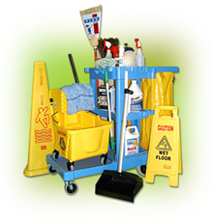
Cleaner/ Caretaker – CE Scheme
Duties to include: Maintain a high standard of cleanliness and hygiene, prepare rooms for groups.
Location: Ballyogan/Carrickmines
Job Title: Cleaner /Caretaker
Hours: 19.5hrs /week
Skills Required: No experience necessary as full training will be provided.
Ref: #CES-2168735
Eligibility to participate on CE is generally linked to those who are 21 years or over and applicants must also be in receipt of a qualifying Irish social welfare payment for 1 year or more.
Contact: Local Intreo Office / LES
Mary Dempsey
CE Supervisor
DLR CE Scheme
Mobile: 086 3679171
cesprogression@gmail.com
