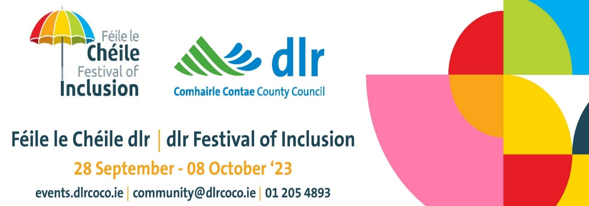

Belonging | Muintearas

Dún Laoghaire-Rathdown (dlr) County Council is delighted to host the dlr Festival of Inclusion every autumn. The aim of the annual dlr Festival of Inclusion is to highlight and celebrate social inclusion initiatives and to support and encourage all to actively participate and engage in the community.

dlr Festival of Inclusion is a community based social inclusion events programme that promotes the many groups, organisations and volunteers organising activities and events and offering supports in the community. All events involve groups and organisations bringing people together to connect and celebrate community well-being and raise awareness, provide supports and promote equality, diversity and social inclusion in dlr.

‘Belonging | Muintearas’ is our overall festival theme this year and the festival will run from Thursday 28th September – 8th October 2023.
Dún Laoghaire-Rathdown County Council invite all individuals, community and voluntary groups, organisations, charities, clubs, associations etc. to organise an event to promte ‘Belonging’ in your community this autumn during the dlr Festival of Inclusion.

A small grants programme is available from Dún Laoghaire-Rathdown County Council to help groups with the costs of running events during the dlr Festival of Inclusion – see application form below and we look forward to showcasing dozens of community groups and organisations hosting activities, exhibitions, performances, talks, coffee mornings, training events, seminars, workshops etc. to promote ‘Belonging | Muintearas’ during dlr Festival of Inclusion 2023.

Closing date for receipt of funding applications and details of events for inclusion in 2023 dlr Festival of Inclusion programme: Friday 25th August 2023

Further information available from: Community Section, Dún Laoghaire-Rathdown County Council - 01 205 4893 / community@dlrcoco.ie
dlr Festival of Inclusion 2023, Community Section, Dún Laoghaire-Rathdown County Council, County Hall, Dún Laoghaire, Co. Dublin, A96 K6C9.

Join us and be part of the dlr Festival of Inclusion 2023!

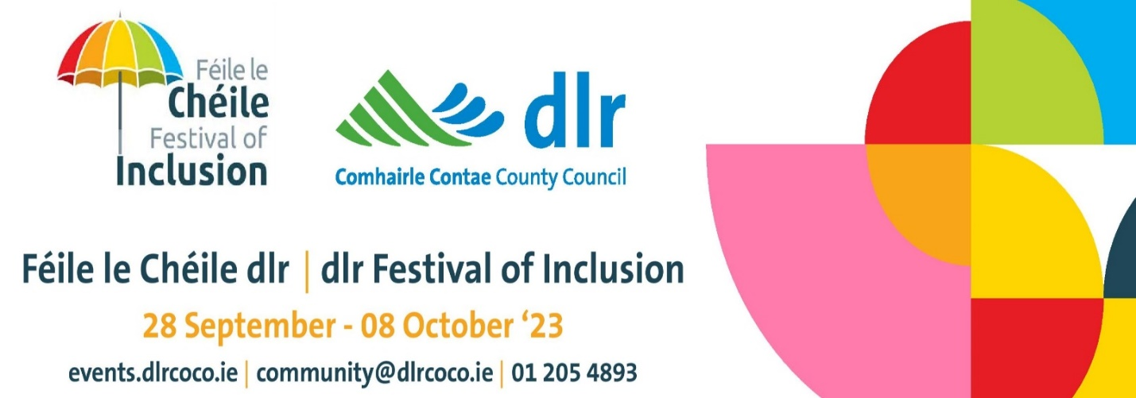

Belonging | Muintearas

Section 1: Details of your Group / Organisation:

Name of Group / Organisation:

Postal Address & Eircode:

Contact Name:
Email Address:
Phone Number:
Website:

Social Media Links:
Brief description of the activities of your group / organisation and the work that you do in the community - Maximum 100 words:

Section 2: Details of your Event as part of dlr Festival of Inclusion’23:

Name of event / activity / exhibition as part of dlr Festival of Inclusion 2023: (for inclusion in promotional materials, dlr website, social media etc.)

Brief description of the event – Maximum 80 words: (this will be the final description used on promotional material, website, social media etc.)

Day, Date and Time of event:

Location of event

(venue / on line):

How to register:
(for example: All welcome – no booking required / Booking details - phone number, email address, Eventbrite details etc.)
No personal contact numbers or emails can be included here

Image / Flyer required or Group Logo (for inclusion in dlr Festival of Inclusion promotional material, website, social media)

How are you going to advertise & promote your event?
(All organisers must promote your own event in your community & take responsibility for all aspects of the event management.)

Are you working with other groups / organisations in planning your event? If so, please name them here:
Is your event accessible? We would encourage that all events be accessible (provided free / at low cost, be accessible to people with disabilities, wheelchair users, hard of hearing, dementia inclusive, age-friendly etc.)
Amount of funding required from dlr County Council Age-Friendly Programme & Social Inclusion Unit to help run this event? (dlr Festival of Inclusion has a small events fund for groups to organise events during the festival)

- I hereby confirm that we will plan, organise, take full responsibility for event management and risk management and will promote the above event as part of the dlr Festival of Inclusion 2023.
- I confirm that our group / organisation has our own Insurance cover for this event.
- I confirm that no personal contact details are included in the information above.
- I confirm that all volunteers and facilitators are fully Garda Vetted, if a young person’s event
- I consent for the information I have supplied above to be included in the dlr Festival of Inclusion 2023 promotional material, dlr website and social media platforms. Dún Laoghaire-Rathdown County Council will publish dlr Festival of Inclusion promotional material in digital and paper format and it is not possible to withdraw consent to being included on promotional material after printing and distribution.
- I hereby confirm that invoices will be provided to dlrcc for event proposed and payment will be made by dlrcc on receipt of invoices, if applicable.

Signed: _______________________________________________________

Group / Organisation: ___________________________________________

Date: ________________________________________________________

Please return application form by Friday 25th August 2023 to:
dlr Festival of Inclusion 2023, Community Section, Dún Laoghaire-Rathdown County Council, community@dlrcoco.ie / 01 205 4893 or post to:
dlr Festival of Inclusion 2023, Community Section, Dún Laoghaire-Rathdown County Council, County Hall, Dún Laoghaire, Co. Dublin, A96 K6C9.

