**Dún Laoghaire-Rathdown Arts Office announces**

**Musicians in Residence 2015-16**

Dún Laoghaire-Rathdown Arts Office is delighted to announce the musicians in residence for 2015-16. Each residency will offer the musicians rehearsal time in the dlr LexIcon studio and will allow the public opportunities to attend performances of the new music that has been composed. The musicians in residence were selected by Deirdre McCrea, Alec O’Leary and Fergus Sheil.

The inaugural residency was awarded to Jazz drummer, composer and bandleader **Matthew Jacobson**. He completed his BA in Jazz Performance at Newpark Music Centre and has a Masters Degree in Music Performance from Lucerne University, Switzerland. In 2013/14 he received a Fulbright Scholar Award to spend nine months immersed in the New York creative music scene. As well as performing with and leading his own quartet ReDiviDeR, Matthew plays regularly with leading Irish groups including Ensemble Ériu, Francesco Turrisi's Taquin Experiments and Chris Guilfoyle's UMBRA and in Europe with AERIE, Blowout Fracture and Foluain Trio.

The second residency will see a collaboration between classical soprano **Elizabeth Hilliard** and composer **Grainne Mulvey**. Elizabeth brings a dramatic quality and emotional intensity to her performance of solo, chamber and vocal ensemble music. She collaborates regularly with visual artists, poets, dancers and theatre-practitioners in the creation of new work. For this residency she is collaborating with classical composer Grainne Mulvey. Grainne’s music has been performed and broadcast across the globe. She is Head of Composition at the DIT Conservatory of Music and Drama. She is also a member of the AIC, IAWM, IMRO, Donne In Musica, Italy and Aosdána, Ireland’s organisation of creative artists.

**The Eidola Trio** which is made up of **Malachy Robinson** (viola de gamba), **Eamonn Sweeney** (baroque guitar, lute)and **Anita Vedres** (baroque violin) will be in residence in Spring 2016. Admitting that even painstakingly accurate historical recreation cannot bring us back in time, they seek to bring period performance to the contemporary audience in a different way: what if a seventeenth-century trio were parachuted into the 21st-century? How would they react to our current musical environment? Given the predilection for improvisation and spontaneity in that era, they would be unlikely to stay strictly within their familiar modes. So they bring the textures and sonorities of their historical instruments in repertoire ranging from the very ancient to the brand new.

The final residency was awarded to emerging musician **Sebastian Adams**. Sebastian is a composer, concert producer, viola player and computer musician based in Dundrum. He is highly active in the field of contemporary music and has composed over 60 works and his music has been performed by many of Ireland’s top performers. His competing focuses as a composer are large-scale acoustic works and real time computer-aided composition.

Dún Laoghaire-Rathdown Arts Office is thrilled to welcome the musicians in residence and is excited to hear the new work that will be composed throughout their time in the LexIcon.

For more information on the Musicians in Residence Scheme or dlr Arts please contact [cbrown@dlrcoco.ie](mailto:cbrown@dlrcoco.ie) or (01) 236 2759.

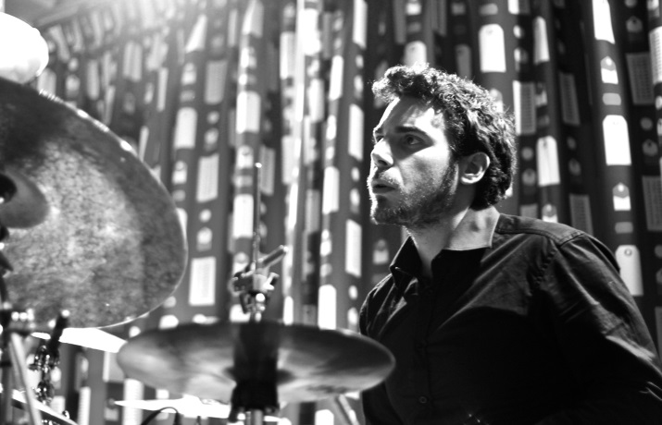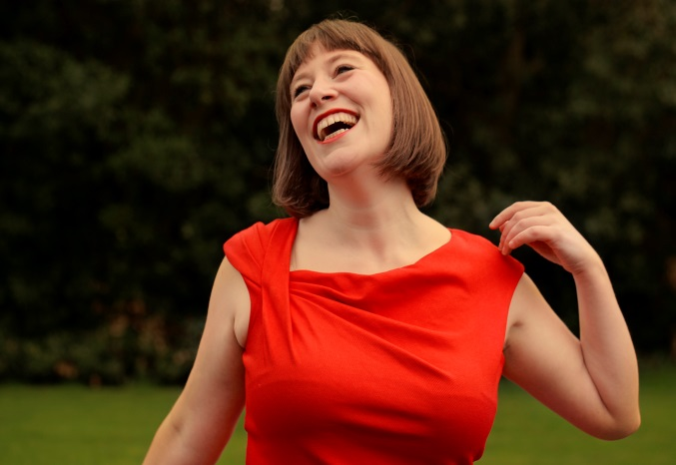

Matthew Jacobson Elizabeth Hilliard

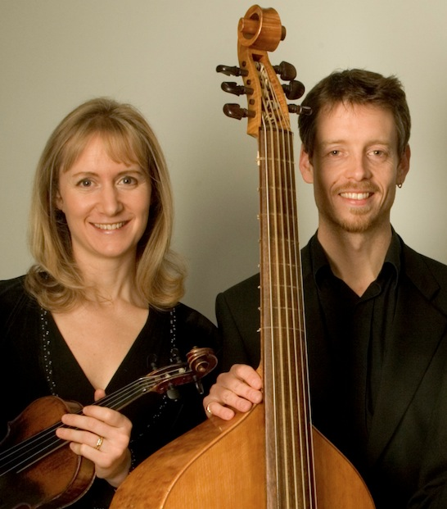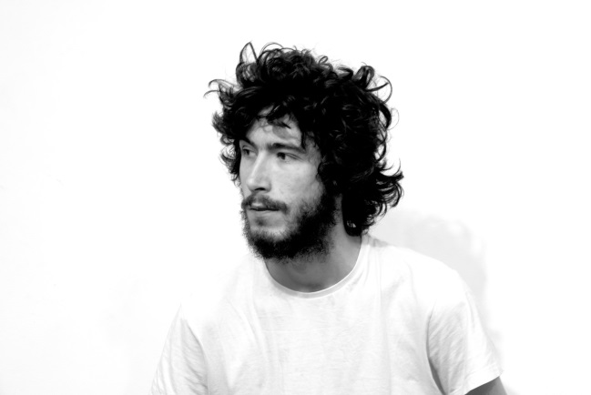

Anita Vedres and Malachy Robinson Sebastian Adams

